BBD UNIVERSITy

SCHOOL OF COMPUTER APPLICATION
ASSIGNMENT ON
Descriptive Analytics

SUBMITED TO :
SUBMITTED BY:
VANSHIKA RAJ
1250258499

VANSHIKA RAJ
12502584099
BCA DS 27
MS. MONIKA RAO

Descriptive Analytics Report:
Sales and Customer Analysis
Customer Rating Analysis ,Regional Revenue Analysis, Total Revenue Generated, Most Used Payment Method, Total Revenue By Payment Method, Revenue Distribution By Region

NOTE ON DATA:
This report is based on an e-commerce sales dataset consisting of 100 transaction records collected over a period of three months (January 2024 to March 2024). The dataset contains detailed information related to customer purchases, including order details, product categories, product IDs, sales revenue, quantity sold, discount percentages, customer ratings, payment methods, and customer regions.
The dataset covers 6 product categories, namely Sports, Books, Electronics, Fashion, Beauty, and Home & Kitchen, representing a diverse range of products sold through the online platform. Customer transactions were recorded across 4 major regions: North America, Europe, Asia, and the Middle East, providing valuable insights into regional sales performance and customer purchasing behavior. The dataset also includes 5 payment methods: Cash on Delivery, Wallet, Credit Card, UPI, and Debit Card, enabling the analysis of customer payment preferences and transaction patterns.

Objective
- Which product category generates the highest total revenue?
- What is the average customer rating for each product category?
- Which customer region contributes the highest total revenue?
- Which payment method generates the highest total revenue?
- Which payment method is used most frequently by customers?
- Which are the top 10 products based on total revenue generated?

How this would work at real scale?
LAYER | PURPOSE | TYPICAL TOOLS
Data Collection | Store sales transaction records including product category, revenue, ratings, discounts, and customer information | CSV Dataset
Data Loading | Import and load the dataset into the analysis environment | Pandas
Data Cleaning | Check missing values, data types, duplicates, and prepare data for analysis | Pandas
Data Analysis | Calculate revenue, ratings, regional performance, payment method usage, and product performance metrics | Pandas, NumPy
Data Visualization | Create charts and graphs to identify trends and patterns | Matplotlib
Reporting | Present findings and business insights in a structured notebook report | Jupyter Notebook

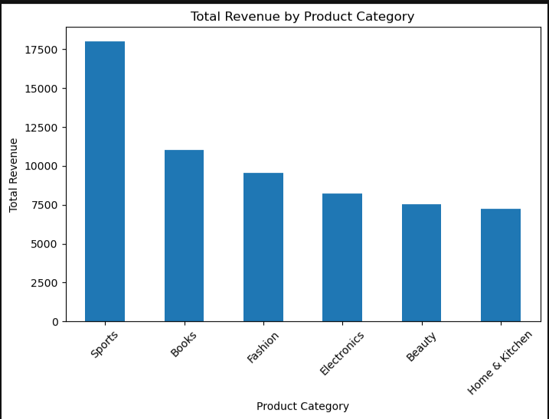
- Customer Rating Analysis

Observation:
The chart clearly shows a significant difference in revenue generation among the six product categories. Sports is the highest revenue-generating category with approximately $18,000 in total revenue, accounting for nearly 29% of the overall dataset revenue of $61,657.46. This indicates that customers purchase Sports products more frequently or spend more per transaction in this category. Books ranks second with approximately $11,000 in revenue, followed by Fashion at around $9,500. These categories demonstrate strong market demand and contribute substantially to overall business performance. Electronics occupies the middle position with approximately $8,200 in revenue, indicating stable but comparatively lower sales performance than the top categories. Beauty and Home & Kitchen are the lowest-performing categories, generating approximately $7,500 and $7,200 respectively. The revenue difference between the highest-performing category (Sports) and the lowest-performing category (Home & Kitchen) is nearly $10,800, highlighting a considerable gap in customer demand and purchasing behavior. The graph suggests that Sports products are the primary revenue drivers of the business, while categories such as Beauty and Home & Kitchen may require additional promotional strategies, pricing improvements, or product diversification to enhance their contribution to overall sales. Overall, the revenue distribution demonstrates that sales are concentrated in a few high-performing categories rather than being evenly distributed across all product segments.

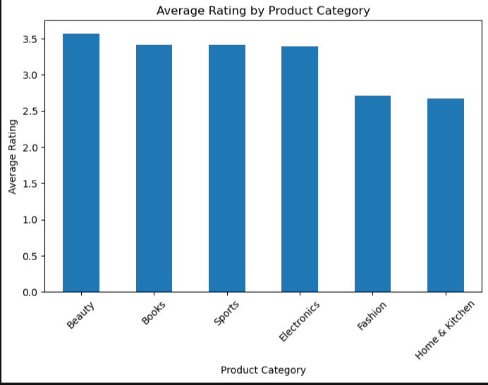
- Regional Revenue Analysis

Observation:
The bar chart compares the average customer ratings across six product categories: Beauty, Books, Sports, Electronics, Fashion, and Home & Kitchen. Among all categories, Beauty has the highest average rating of approximately 3.6 out of 5, indicating that customers are generally more satisfied with products in this category. Books, Sports, and Electronics follow closely with average ratings of around 3.4 to 3.5, showing relatively consistent customer satisfaction and positive product experiences. These categories perform above the overall average rating of 3.24, suggesting that they meet customer expectations more effectively. In contrast, Fashion and Home & Kitchen have the lowest average ratings, approximately 2.7 to 2.8, indicating comparatively lower customer satisfaction levels. The difference between the highest-rated category (Beauty) and the lowest-rated category (Home & Kitchen) is nearly 0.9 rating points, which represents a noticeable variation in customer perception. Overall, the chart shows that customer ratings are not evenly distributed across categories. While Beauty, Books, Sports, and Electronics demonstrate strong performance and customer approval, Fashion and Home & Kitchen may require improvements in product quality, pricing, features, or customer support services to enhance customer satisfaction and improve future ratings. These findings provide valuable insights into customer preferences and can help businesses prioritize quality improvements in lower-performing categories while maintaining the strengths of higher-rated categories.

- 3. REVENUE DISTRIBUTION BY REGION
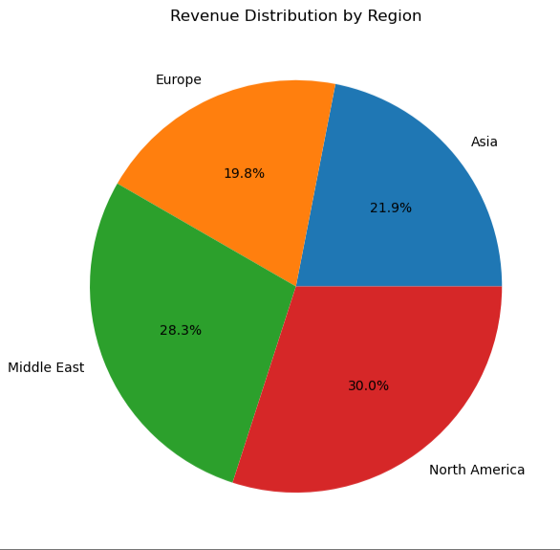
Observation:
The pie chart provides a clear comparison of revenue distribution across four customer regions: North America, Middle East, Asia, and Europe. Among all regions, North America contributes the highest share of total revenue at 30.0%, indicating that it is the strongest market in terms of sales performance and customer purchasing activity. The Middle East ranks second with 28.3%, contributing only slightly less than North America and demonstrating strong revenue generation potential. Asia accounts for 21.9% of the total revenue, placing it in the middle range and reflecting a moderate level of customer demand and market performance. On the other hand, Europe contributes the lowest share at 19.8%, making it the least significant revenue contributor among the four regions. The difference between the highest-performing region (North America) and the lowest-performing region (Europe) is approximately 10.2 percentage points, highlighting noticeable variations in regional sales performance. Overall, the graph shows that revenue generation is not evenly distributed across regions, with North America and the Middle East together contributing more than half of the total revenue. These findings suggest that businesses should continue strengthening their presence in high-performing regions while exploring strategies to increase customer engagement and sales growth in lower-performing markets such as Europe and Asia.

- TOTAL REVENUE BY PAYMENT METHOD
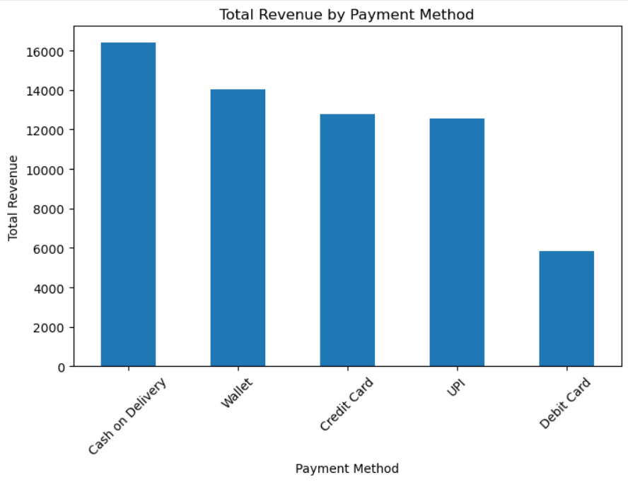
Observation:
The bar chart compares the total revenue generated through five payment methods: Cash on Delivery, Wallet, Credit Card, UPI, and Debit Card. Among all payment methods, Cash on Delivery generates the highest revenue of approximately $16,500, making it the most significant contributor to overall sales revenue. This indicates that a large number of customers prefer paying upon delivery, likely due to the convenience and trust associated with this payment option. Wallet payments rank second with approximately $14,000 in revenue, demonstrating the growing adoption of digital payment solutions among customers. Credit Card and UPI contribute nearly similar amounts, generating approximately $12,800 and $12,600 respectively, indicating moderate customer preference and consistent usage. In contrast, Debit Card generates the lowest revenue at approximately $5,800, contributing significantly less than all other payment methods. The difference between the highest-performing payment method (Cash on Delivery) and the lowest-performing payment method (Debit Card) is approximately $10,700, highlighting a substantial variation in customer payment preferences. Furthermore, Cash on Delivery alone contributes nearly 27% of the total dataset revenue of $61,657.46, while Debit Card contributes less than 10%. Overall, the chart reveals that customers strongly favor Cash on Delivery and digital wallet payments, whereas Debit Card transactions are comparatively less common. These insights can help businesses focus on optimizing their most preferred payment channels while identifying opportunities to encourage greater adoption of lower-performing payment methods through promotional offers and improved transaction experiences.

- MOST USED PAYMEMT METHOD

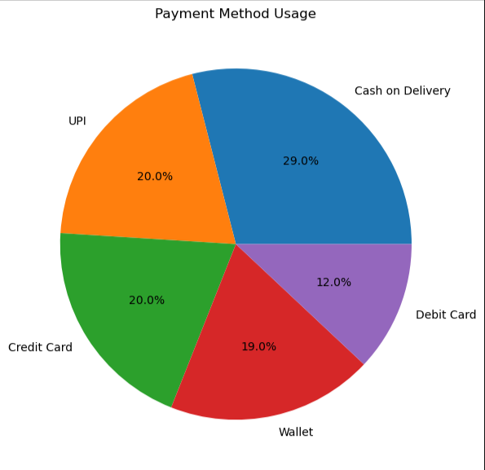
Observation:
The pie chart illustrates the distribution of customer transactions across five payment methods: Cash on Delivery, UPI, Credit Card, Wallet, and Debit Card. The analysis reveals that Cash on Delivery is the most frequently used payment method, accounting for 29% of all transactions. This indicates that nearly one-third of customers prefer paying at the time of delivery, suggesting a high level of trust and convenience associated with this payment option.
Both UPI and Credit Card contribute 20% each, making them the second most preferred payment methods among customers. Their equal share demonstrates the growing acceptance of digital payment solutions and cashless transactions. Wallet payments account for 19% of total transactions, which is only slightly lower than UPI and Credit Card usage, indicating that digital wallets remain a popular choice for online purchases.
In contrast, Debit Card is the least used payment method, contributing only 12% of total transactions. This suggests that customers may prefer alternative digital payment methods such as UPI and Wallets over traditional debit card payments. The difference between the highest-used payment method (Cash on Delivery at 29%) and the lowest-used payment method (Debit Card at 12%) is 17 percentage points, highlighting a noticeable variation in customer payment preferences.
Overall, the chart demonstrates that customer transactions are fairly distributed across multiple payment methods, although Cash on Delivery remains the dominant option. Digital payment methods collectively account for 71% of all transactions, indicating a strong shift toward electronic payment systems. These findings suggest that businesses should continue supporting a wide range of payment options while focusing on optimizing the most preferred channels to enhance customer convenience and improve the overall purchasing experience.

- Total revenue generated?
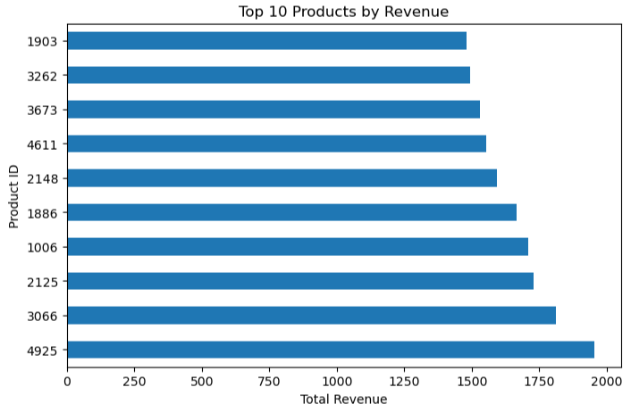
Observation:
The horizontal bar chart presents the Top 10 products ranked according to total revenue generated. The analysis reveals that Product ID 4925 is the highest-performing product, generating approximately $1,950 in revenue. This product contributes the largest share among the top-performing products and can be considered the strongest revenue driver within the dataset.
Product ID 3066 ranks second, generating approximately $1,820, followed by Product IDs 2125 and 1006, which generated around $1,750 and $1,720 respectively. These products demonstrate strong sales performance and consistently contribute to overall business revenue. The middle-performing products, including 1886, 2148, 4611, and 3673, generate revenue ranging between $1,550 and $1,670, indicating relatively stable sales performance.
At the lower end of the top ten list, Product IDs 3262 and 1903 generated approximately $1,500 and $1,480 respectively. Although they rank lower within the top ten, they still contribute significantly to the overall revenue and outperform many other products in the dataset.
The difference between the highest-performing product (4925) and the lowest-ranked product in the top ten (1903) is approximately $470, suggesting that the top products generate relatively similar levels of revenue. The combined revenue of these top 10 products is approximately $16,560, which represents a significant portion of the total dataset revenue of $61,657.46. This indicates that a relatively small group of products contributes substantially to overall business performance.
Overall, the chart highlights the importance of identifying high-performing products for inventory management, marketing campaigns, and sales strategies. Products such as 4925 and 3066 should be prioritized for stock availability and promotional activities, while the performance patterns of these products can be studied to improve the sales of lower-performing products.

KPI:
KPI | Value
Best Performing Product | Product ID 4925
Revenue of Best Performing Product | ~$1,950
Second Best Performing Product | Product ID 3066
Revenue of Second Best Product | ~$1,820
Lowest Revenue Product in Top 10 | Product ID 1903
Revenue of Lowest Ranked Top Product | ~$1,480
Total Revenue of Top 10 Products | ~$16,560
Revenue Gap (Highest vs Lowest) | ~$470
Number of Products Analyzed | 10
Average Revenue per Top Product | ~$1,656
Top Revenue Contributor | Product ID 4925
Revenue Concentration | Top 10 Products contribute a significant share of overall sales
- Summary of Key Metrics

MATRIX | VALUE
Total Revenue Generated of top 10 products | ≈ $16,560
Number of Product categories | 6
Number of Customer Regions | 4
Number of Payment Methods | 5
Most Frequently Used Payment Method | Cash on Delivery
Highest Revenue Generating Category | Sports
  Highest Revenue Generating Product
  Product ID 4925
Highest Revenue Region | North America (30.0%)
Lowest Revenue Region | Europe (19.8%)
9. Moving from Descriptive Analytics to Predictive Analytics
This project primarily focuses on descriptive analytics, which answers the question "What happened?" by analysing historical sales and customer transaction data. Through revenue analysis, customer ratings, product performance evaluation, regional sales comparisons, and payment method analysis, the project provides insights into past business performance and customer behaviour.
The next stage of analytics is predictive analytics, which aims to answer the question "What is likely to happen in the future?". By using historical data patterns identified in this project, predictive models can be developed to forecast future business outcomes.
The following predictive applications can be implemented using the current dataset:
- Sales Forecasting: Predict future revenue and sales trends based on historical transaction patterns.
- Demand Prediction: Estimate future demand for specific product categories to improve inventory planning.
- Customer Rating Prediction: Predict customer satisfaction levels based on product characteristics and previous ratings.
- Regional Sales Forecasting: Forecast future sales performance across different customer regions.
- Product Performance Prediction: Identify products that are likely to become top sellers in the future.
- Customer Purchase Behavior Analysis: Predict customer preferences and purchasing patterns to support targeted marketing strategies.
To move from descriptive to predictive analytics, machine learning algorithms such as Linear Regression, Decision Trees, Random Forest, and Time Series Forecasting Models can be applied to the existing sales dataset. These models would enable businesses to anticipate future trends, optimize inventory management, improve customer satisfaction, and make proactive business decisions.
Thus, while descriptive analytics explains past performance, predictive analytics extends the value of the project by helping organizations prepare for future opportunities and challenges through data-driven forecasting and decision-making.

-APPENDIX
Attribute | Description
order_id | Unique identifier for each order
order_date | Date on which the order was placed
product_id | Unique identifier for each product
product_category | Category to which the product belongs
price | Original price of the product
discount_percent | Discount applied to the product
quantity_sold | Number of units sold
customer_region | Region from which the order was placed
payment_method | Method used for payment
rating | Customer rating for the product
review_count | Number of customer reviews
discounted_price | Final price after discount
total_revenue | Revenue generated from the transaction

